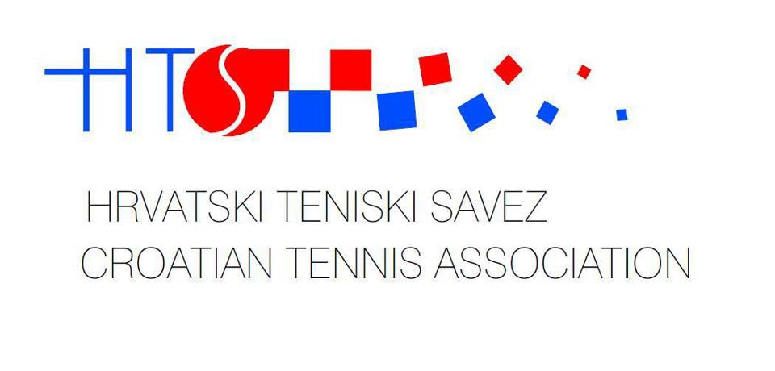
ZBOR TENISKIH SUDACA HRVATSKE
10000 Zagreb, Gundulićeva 3

IBAN: HR2423600001502175985

ITF World Tennis Tour – W60 - ZAGREB LADIES OPEN 2019

Supervisor: Mila Mandl

BB designated: Manuel Weiss
WB designated: Marko Pleše
WB designated: Ana Pipan

National: Alen Milanović
National: Ales Fras

